Title: Can a Social Robot be a Creative Partner?
Principal Investigators
Dr. Jan de Wit, TSHD (J.M.S.deWit@tilburguniversity.edu) Dr. Maryam Alimardani, TSHD (m.alimardani@tilburguniversity.edu) Dr. Alwin de Rooij, TSHD (AlwindeRooij@tilburguniversity.edu)

Experimenters
Caterina Ceccato, TSHD (c.ceccato@tilburguniversity.edu) Ethel Pruss, TSHD (e.pruss@tilburguniversity.edu) Jos Prinsen, TSHD (j.m.prinsen@tilburguniversity.edu) Anita Vrins, TSHD (a.m.vrins@tilburguniversity.edu)

Introduction

You are invited to participate in a research study on the topic of creativity and brainstorming with a social robot. You will be asked to brainstorm ideas with the help of a robot called Furhat (see Figure 1). Please read this information letter and ask any questions you may have before agreeing to participate in the study.

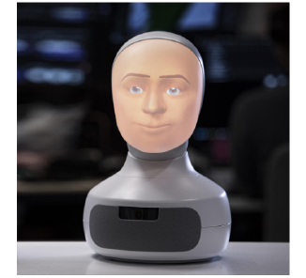
Figure 1. Furhat robot.

Purpose of the Study

The purpose of this study is to investigate whether a social robot can be a useful partner during a creative brainstorming task. You are expected to fill out surveys before and after the interaction with the robot, and also participate in a semi-structured interview at the end.

Disclaimer: The task will require you to listen to the robot’s speech to guide the brainstorming session. It will try to engage you in a conversation by asking you questions and exchanging ideas.

Please do not share any sensitive information during the robot interactions such as your full name, address, or any other information that could be used to personally identify you.

Study Procedure

Once you agree to participate in this study, you will be asked to fill out a short questionnaire with a few questions regarding your background information. The robot is equipped with a microphone, you are expected to speak to the robot during the brainstorming interactions. You will perform 2 rounds of brainstorming with the robot in total. After each round, you will be asked to fill in a questionnaire.

Finally, we will conduct a short interview with you so you can share your experience with Furhat in more detail. (See Figure 2 for a timeline.)
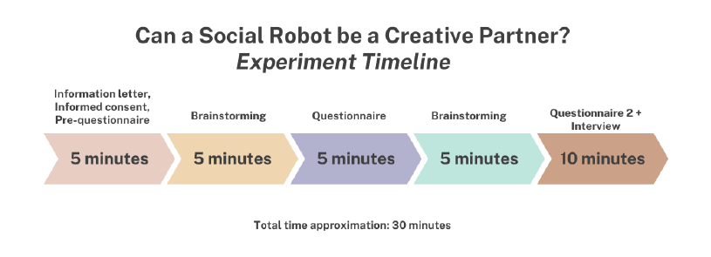
Figure 2. Experiment timeline.

Duration of Experiment
The study will take around 30 minutes to complete. Please see the approximate timeline in the following figure:
Conditions and Risks
Participants must be at least 18 years of age and give informed consent to participate. The study poses no additional risks beyond those encountered in everyday life.

If you experience any excessive discomfort or feel that you do not want to continue the study for any reason, please let the experiments know immediately. There are no negative consequences for not completing the study. Your participation in this study will contribute to a better understanding of collaborative brainstorming.

You will receive 0.5 course credits on SONA for your participation. If you decide to quit the ongoing experiment for any reason, you will be awarded SONA points proportionally to the time spent in the experiment. Upon completing the full study, you will receive the full 0.5 SONA points regardless of the actual duration of the experiment in minutes.

Confidentiality and Privacy

Your identity will be kept strictly confidential. We will collect your answers to the questionnaires as well as an audio transcript of the post-interaction interview. Once all data is collected, all data files and documents will be anonymized and there will be no way of personally identifying your data in any reports of the completed study.

All collected data will be stored on the password-protected SurfDrive accessible only to the immediate research team. No identifying, personal, or contact information will be included in the stored data. For this reason, your responses will be anonymous.

Your participation in this research is voluntary. You have the right to decline to participate and withdraw from the research once participation has begun, without any negative consequences, and without providing any explanation. You have the right, in principle, to request access to and rectification, erasure, restriction of or object to the processing of the personal data. For more information: www.tilburguniversity.edu/privacy.

Contact Information

This study has been approved by the TSHD Research Ethics and Data Management Committee.

If you have any questions or want further information concerning this study, please contact the Principal Investigator, dr. Jan de Wit (J.M.S.deWit@tilburguniversity.edu) and/or the experimenters:

Caterina Ceccato, TSHD (c.ceccato@tilburguniversity.edu)
Ethel Pruss, TSHD (e.pruss@tilburguniversity.edu)
Jos Prinsen, TSHD (j.m.prinsen@tilburguniversity.edu)
Anita Vrins, TSHD (a.m.vrins@tilburguniversity.edu)

If you have any concerns or complaints about your rights as a research participant and/or your experiences while participating in this study, contact the “Research Ethics and Data Management Committee” of Tilburg School of Humanities and Digital Sciences via tshd.redc@tilburguniversity.edu.
Consent

It is assumed that if you participate in this experiment you have provided consent to participate. However, you have the right to refuse to participate or to withdraw your participation at any time by simply leaving the room, and you will still receive the SONA points proportional to the time spent in the experiment. On the next page, you will sign the "informed consent form". You may print this consent form to have a copy for your records. Please do not hesitate to ask any questions you may have before signing this form.

Informed Consent
Title of Study: Can a Social Robot be a Creative Partner?
By signing this form, you acknowledge that (please choose your answer):

You have read and understood the information letter, and have had the opportunity to ask questions.
- Yes
- No

Your participation in the study is voluntary.
- Yes
- No

You are aware that you may choose to terminate your participation at any given time without any reason.
- Yes
- No

You are 18 years of age or older.
- Yes
- No

You are aware of any (dis)advantages of participation in the experiment.
- Yes
- No

You give us permission to process your anonymized data.
- Yes
- No

You give us permission to store the research data for a period of ten years.
- Yes
- No

You agree that all data that has been collected may be passed on (anonymously) to other researchers.
- Yes
- No

I hereby voluntarily agree to participate in the study mentioned above.
- I agree

Participant name:
________________________________________________________________

Today's date (DD/MM/YY):
________________________________________________________________

Add your signature here:

